QUICK START TO “ORGANIC SYNTHESIS”

This program was written for everyone who comes in contact with A-level chemistry. Become familiar with organic synthesis while using the program, practise and enjoy the game.

- The program is placed in: Pulpit/Public Folders/Chemistry/Organic synthesis.
Log on to DC intranet. There is a shortcut to Public Folders on the windows’ pulpit. Use left mouse button to open it. You should see a window with the contents of Public Folders. Go to ‘Chemistry’ folder. Inside, you will find a folder named ‘Organic synthesis’. Open it and go into icon ‘Chemistry’. Click on it.
Your screen should look more or less like this:

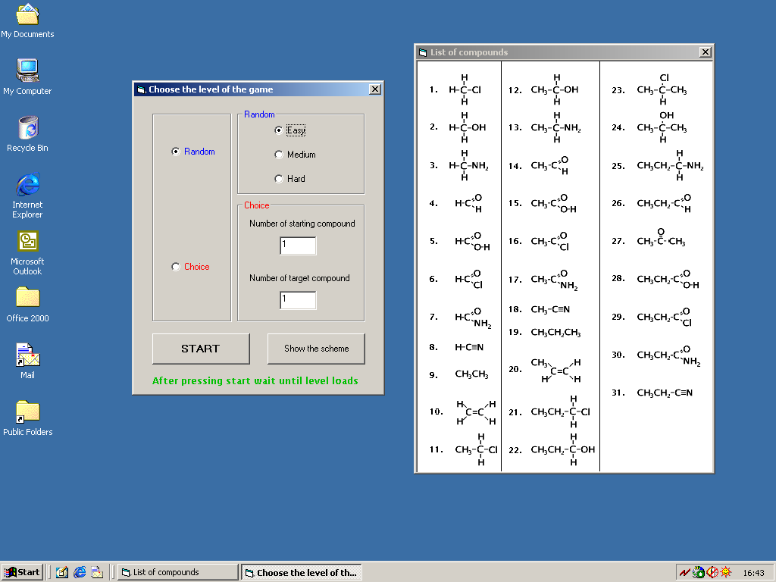

- Press ‘Start’ button to initialise your game. The computer will choose ‘Starting compound’ and ‘Target compound’ randomly. If you want to do this on your own, click on ‘Choice’ and state your conditions.
- As soon as you clicked ‘Start’ button, you should have seen this:

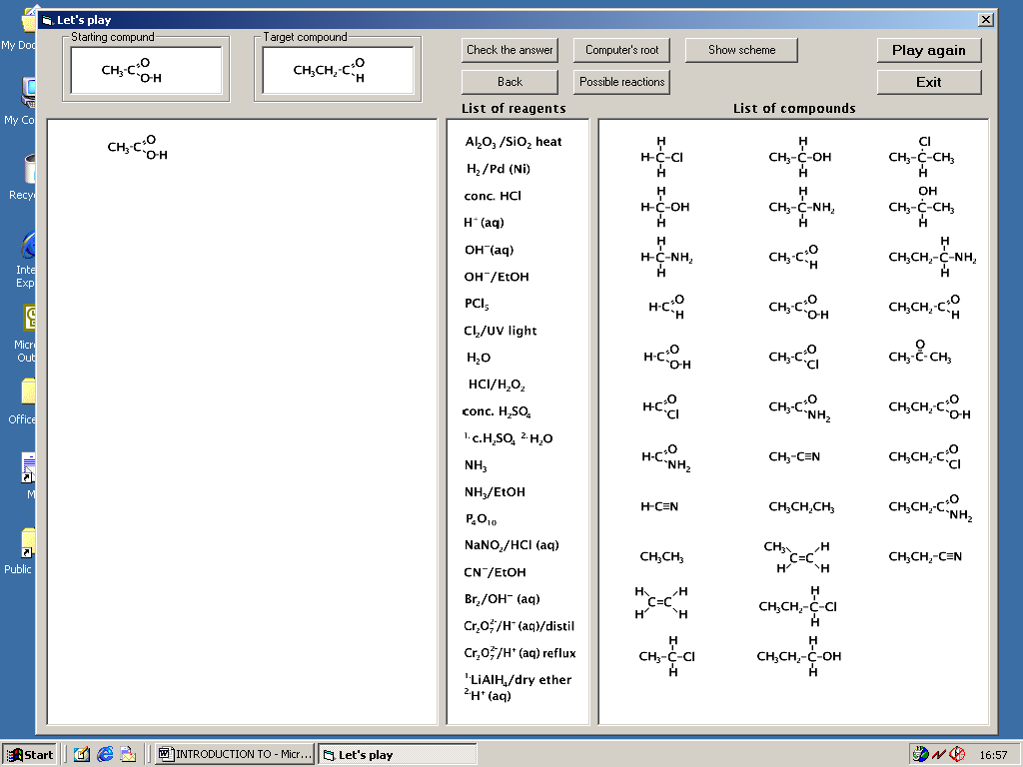

- At the top you should recognize your ‘Starting compound’ and ‘Target compound’. Construct the complete synthesis by clicking on reagents from ‘List of reagents’ and compounds from ‘List of compounds’.
- If you make a mistake, press ‘Back’ button to step back.
- To check your answer, click on ‘Check the answer’.
- To start the game from the beginning press ‘Play again’, to close it press ‘Exit’ button.

Help menus:

- You could view possible reactions of the last compound you have selected by clicking on ‘Possible reactions’ button.
- To let the computer find a route for you click on ‘Computer’s route’.
- ‘Show scheme’ button - the scheme shows relationships between functional groups, within molecules with three carbon atoms (this is integral to the game!).

